Name: _________________________________________________________________________ MI: _______________

Address: __________________________________________________________________________________________

City: __________________________________ State: ___________________ Zip: ______________________________
Home Phone: ______-______-_______Work Phone: ______-______-_______ Cell Phone: ______-______-___________
Email Address: _____________________________ Occupation: _____________________________________________
Date of Birth: ________________________ Social Security #: _______-______-_______ Gender: Male - Female
Race/Ethnicity: Caucasian American Indian African-American Hispanic/Latino Other: _____________________
Employer: ___________________________________ Spouse’s Name: __________________________________
Emergency Contact (Name and Phone): __________________________________________________________________

How did you find out about our office?
Phone Book Internet Radio Newspaper
Personal Referral (Please specify so we may thank them): ____________________________________________________
Other (Please specify): ________________________________________________________________________________

Have you had chiropractic care before? ( Y /N ) If yes, where? _____________________________________________

All information provided is kept in strict confidence.

Release of Information:
I agree that Park Performance Chiropractic may release information to my health insurer that is required to receive payment from that entity. Information to be released to any other party must be authorized in a separate document.

Financial Responsibility:
I agree to be financially responsible for all charges incurred at this clinic, including my insurance deductible, co-payment, and any services denied by my insurance company. I understand that this clinic may or may not presently be a provider for my insurance company and agree to be responsible for all charges incurred.

HIPAA Notice of Privacy Practices:
I agree that I have been offered a copy of the HIPAA Notice of Privacy Practices and I am agreeing to its terms.

By signing below, I am verifying that I have read all the above information and all information provided is accurate to my knowledge.

Patient Signature: __________________________________________________ Date: _________________________

List any Allergies:

 Animals
 Aspirin
 Bees

 Dairy
 Dust
 Eggs

 Latex
 Molds
 Peanuts

 Penicillin
 Seasonal Allergies
 Soaps

 Sulfa Drugs
 Wheat
 Other: __________

List ALL Past Medical History conditions:

 Ankle Pain
 Arm Pain
 Arthritis
 Asthma
 Back Pain
 Broken Bones
 Cancer
 Chest Pain
 Depression
 Diabetes
 Dizziness
 Elbow Pain
 Epilepsy
 Eye Problems
 Fainting
 Fatigue
 Foot Pain
 Genetic Condition
 Hand Pain
 Headaches
 Hearing Problems
 Hepatitis
 High Blood Pressure
 Hip Pain
 HIV
 Jaw Pain
 Joint Stiffness
 Knee Pain
 Leg Pain
 Menstrual Problems
 Mid-Back Pain
 Minor Heart Problem
 Multiple Sclerosis
 Neck Pain
 Neurological
 Pacemaker
 Parkinson’s
 Polio
 Prostate Problems
 Shoulder Pain
 Spinal Cord Injury
 Sprain/Strain
 Stroke/Heart Attack
 Weight Change
 Other: _______

List your Current Medications, including dosage (continue on back of page if necessary):
___________________________________________________________________________________________________
___________________________________________________________________________________________________

List any Surgeries you have had performed, including the year performed (continue on back of page if necessary):

___________________________________________________________________________________________________

List your Family History:

 Arthritis
 Asthma
 Back Pain
 Cancer
 Depression
 Diabetes
 Epilepsy
 Genetic Condition
 High Blood Pressure
 Heart Problems
 Multiple Sclerosis
 Neurological
 Parkinson’s
 Polio
 Prostate Problems
 Stroke/Heart Attack
 Thyroid problems
 Other: __________

Have you had any auto or other accidents?  No Yes
Describe: ___________________________________________________________________________________

Date of last physical examination: _________________
Have you ever been a user of tobacco products?  No Yes
If yes, what type and how much is currently used per day? ___________________________________________________
Do you drink alcohol?  No Yes - how many per day? _________________________________________________
Do you drink caffeine?  No Yes - how many per day? _________________________________________________
Do you exercise?  No Yes - what forms and how often? ___________________________________________
Main reason for consulting the office:

 Become pain free
 Explanation of my condition
 Learn how to care for my condition
 Reduce symptoms
 Resume normal activity level

PLEASE MARK YOUR AREAS OF PAIN ON THE DIAGRAM BELOW

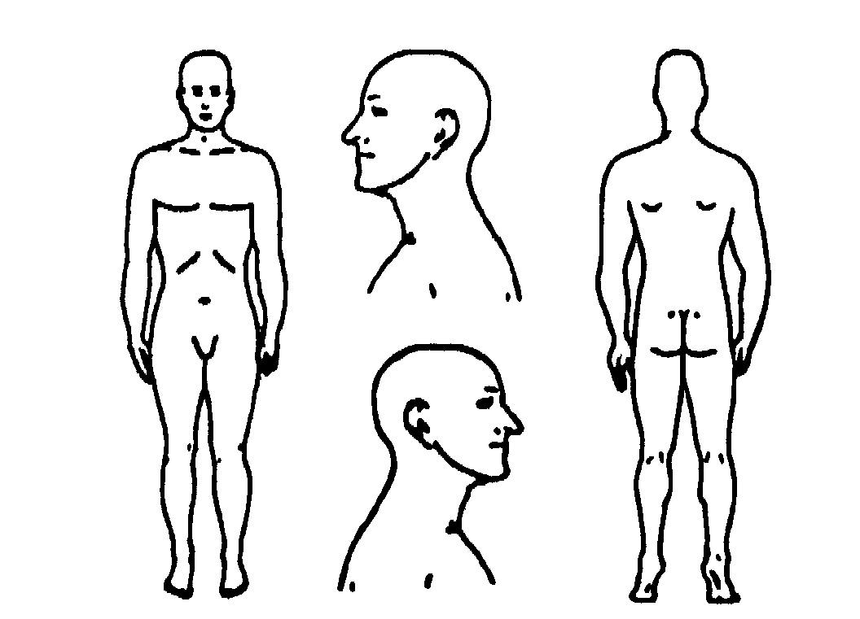
What is your PRIMARY complaint? _________________________________Date problem began? __________________
How did this problem begin (falling, lifting, etc.)? _________________________________________________________
How is your condition changing?  GETTING BETTER  GETTING WORSE  NOT CHANGING
Have you had this condition in the past? YES - NO
How often do you experience your symptoms?
 Constantly (76-100% of the day)  Frequently (51-75% of the day)
 Occasionally (26-50% of the day)  Intermittently (0-25% of the day)
Describe the nature of your symptoms:

 Sharp
 Dull
 Numb
 Burning
 Shooting
 Tingling
 Radiating Pain
 Tightness
 Stabbing
 Throbbing
 Nagging
 Other: _________________

Please rate your pain on a scale of 0 to 10 (0= no pain and 10= excruciating pain)
 0  1  2  3  4  5  6  7  8  9  10
How do your symptoms affect your ability to perform normal daily activities? (0= no effect and 10= no possible activities)
 0  1  2  3  4  5  6  7  8  9  10
What activities aggravate your condition (working, exercise, etc.)? _____________________________________________
What makes your pain better (ice, heat, massage, etc.)? ______________________________________________________

Is there anything else you would like Dr. Nelson to know prior to your treatment today?
____________________________________________________________________________________________________________________________________________________________________________________________________________________________________________________________________________________________________________________________________________________________________________________________________________

INFORMED CONSENT TO TREAT
I hereby request and consent to the performance of chiropractic procedures, including various modes of physiotherapy, diagnostic x-rays, and any supportive therapies on me (or on the patient named below, for whom I am legally responsible) by Dr. Nelson and/or other licensed doctors of chiropractic and support staff who now or in the future are employed by, working or associated with, or serving as back-up for Dr. Nelson, including those working at the clinic or office listed below or any other office or clinic, whether signatories to this form or not.
I have had an opportunity to discuss with Dr. Nelson and/or other office or clinic personnel the nature and purpose of chiropractic adjustments and procedures.
I understand and I am informed that, as is with all healthcare treatments, results are not guaranteed and there is no promise to cure. I further understand and I am informed that, as is with all healthcare treatments, in the practice or chiropractic there are some risks to treatment, including but not limited to: muscle spasms for short periods of time, aggravating and/or temporary increase in symptoms, lack in improvement of symptoms, sprains, strains, fractures, disc injuries, dislocations, and stroke. I do not expect the doctor to be able to anticipate and explain all risks and complications, and I wish to rely on the doctor to exercise judgment during the course of the procedure which the doctor feels, at the time, based upon the facts then known, is in my best interest.
I further understand that there are treatment options available for my condition other than chiropractic procedures. These treatment options include, but are not limited to: self-administered over the counter analgesics and rest; medical care with prescription drugs such as anti-inflammatories, muscle relaxants, and painkillers; physical therapy; steroid injections; bracing; and surgery. I understand and have been informed that I have the right to a second opinion and to secure other opinions if I have concerns as to the nature of my symptoms and treatment options.
I have read, or have had read to me, the above consent. I have also had an opportunity to ask questions about its content, and by signing below I agree to the above-named procedures. I intend this consent to cover the entire course of treatment for my present condition and for any future condition(s) for which I seek treatment.
Name of Patient: ___________________________________________________________________
Signature of Patient: ________________________________________________________________
Date: ____________________________________________________________________________
If patient is a minor, please provide:
Name of Parent/Guardian: ___________________________________________________________
Relationship to Patient: _____________________________________________________________
Signature of Parent/Guardian: ________________________________________________________
Date: ____________________________________________________________________________

